**DELIVERABLE # 1**

## PROJECT BRIEF/DESCRIPTION

Expenditure statistics web application, user can be input into the monthly expenditure according to different types, and set as an automatic payment expenditure copy to the next month, statistics function, to achieve the annual statistical expenditure type by type, and visually display the main expenditure, analyze consumption habits.

## **TASKS PLAN**

List of features: Record monthly expenses and analyze consumption habits. The main consumption of different months can be analyzed each year. Analyze the main consumption throughout the year. Expense exception reminder. You can change your consumption habits in the next year according to the analysis to save money.

Tasks: Analyze the expenses needed to record, understand what the application needs to be displayed, understand the statistics needed, design interface, design case map, class diagram, user story, database graph, application code development, testing, bug repair after testing, and complete the deployment.

User Stories:

|  |  |  |  |  |
| --- | --- | --- | --- | --- |
| User Stories | | | | |
| **ID** | **As a** | **I want to** | **So that** | **Test criteria** |
| 1 | a user | log in | I can access my account | You can see your user home page |
| 2 | a user | register | I can access the Expenditure statistics web application | You will be able to log in successfully after registration |
| 3 | a user | Add a Expenses | I can add a Expenses information | Expenses is added successfully message, check the Expenses page to make sure your Expenses is added |
| 4 | a user | update a Expenses | I can keep a Expenses information up to date | A message showing update is successful / check the Expenses page to make sure changes are made correctly |
| 5 | a user | Remove a Expenses | I can Remove a Expenses | Expenses is Removed successfully message, check the Expenses page to make sure your Expenses is Removed |
| 6 | a user | Add a income | I can add a income information | Expenses is added successfully message, check the income page to make sure your income is added |
| 7 | a user | update a income | I can keep a income information up to date | A message showing update is successful / check the income page to make sure changes are made correctly |
| 8 | a user | Remove a income | I can Remove a income | Income is Removed successfully message, check the income page to make sure your income is Removed |
| 9 | a user | search the Expenses | I can see the Expenses List in the Expenses web page | A list of Expenses. |
| 10 | a user | search the income | I can see the income List in the income web page | A list of income. |
| 11 | a user | View income and expenditure statistics by year or month | I can check income and expenditure statistics by year or month | A list of income and expenditure statistics pages (year or month) |
| 12 | a user | View the analysis of the proportion of consumption in the whole year | I can check by year or month or type | Graphic display |

Estimated completion dates：03-Oct-2022

## **SITEMAP**

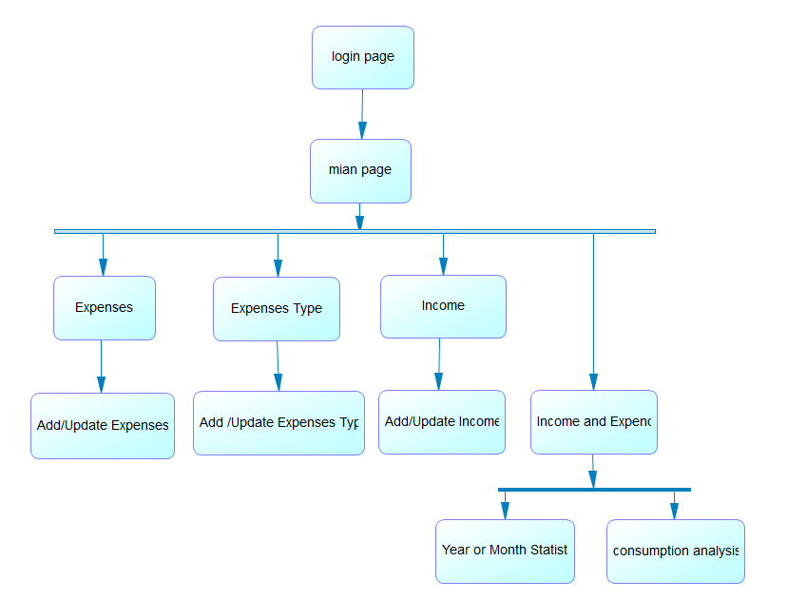

1. **WIREFRAMES**
2. **for the web pages that will be implemented**
   * 1. **Main page**

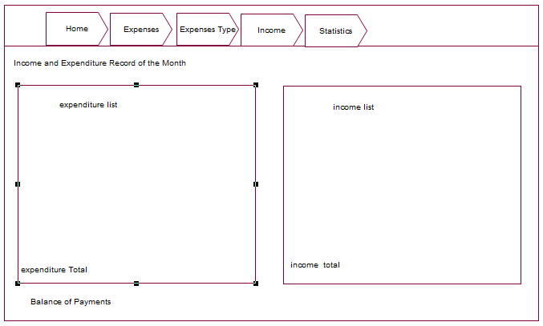

* + 1. **Login page**

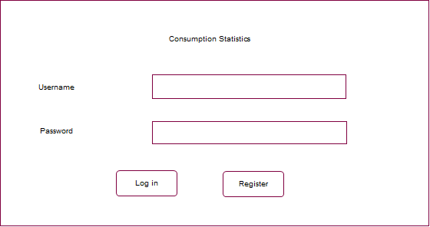

* + 1. **A page with an Edit Form**

